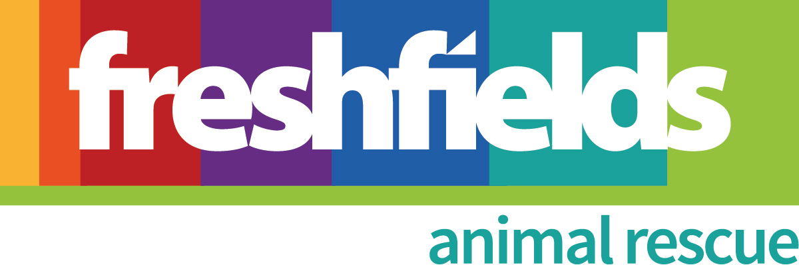
Dog Adoption Application Form

Please ensure that you have read our rehoming criteria in detail before applying to adopt a dog, this will help you to decide whether your circumstances are suitable for adopting. Please complete all sections of this form and return to kennels@freshfields.org.uk and one of our team will be in contact with you in due course. We cannot guarantee a response to forms that are not fully completed.
Please mark the Yes/No boxes by double clicking on them and selecting ‘checked’.

Please only complete this form if you are aged 20 or over!

Your Details

Your Name
Home Address
Postcode
Email
Home Number
Mobile Number
Please provide proof of Identity
This should show name, current address and a photo if possible.
For e.g. Passport, driving licence, utility bill, bank statement.
Occupation
Work hours and days of everyone living in the home
Dog of Interest
About Your Family and Home
How many adults live in your household?
What is the age and sex of every adult in the home:
How many children live in your household?
What is the age and sex of every child in the home:
Do children visit your home? If so, how many and what are their ages? How often do they visit and do they ever stay over? | Yes  No
Is anyone in the home banned from keeping dogs or any other animals? | Yes  No
Does anyone in the home have any illness or disability that may cause difficulties in looking after a dog? For e.g. use of walking aids etc. Please note that we do not discriminate but knowing this information will help us to match you to a suitable dog. | Yes  No
Does anyone in the household have any allergies or asthma? | Yes  No
Is your home owned or rented?  Please note that if you rent your home, we will ask to see written permission from your landlord which states you are able to have dogs at home. | Owned  Rented
What type of property do you live in? | House Flat Other
How long have you lived at this address?
Do you have a garden? | Yes  No
If yes, how secure is the garden? Is it private or communal?
Will the dog live inside or outside? | Inside  Outside
Are you currently having any building/renovation work carried out on the property? | Yes  No
Are you financially secure to take on a dog; can you afford regular vet care and insurance? | Yes  No
Are there currently any other pets in your home? | Yes  No
Please give details of type, breed and ages of any other pets
Are they neutered and fully vaccinated?
On average, how long will the dog be left alone each day?
Where will the dog sleep at night?
If requested, are you able to travel to Freshfields on more than one occasion to form a bond with your new dog before adoption? | Yes  No
Do you have your own vehicle and are you willing to transport a dog in it? | Yes  No
How many walks a day can you provide and for what duration? What walking areas are local to you?

Future Plans

Are there any plans for children in the future? (This includes children due in the family that may visit your home) | Yes  No
Do you have any plans to move house within the next 12 months? | Yes  No
Do you have any plans to emigrate? | Yes  No
Do you have any building or renovation work planned in the next 12 months? | Yes  No
Do you have any plans to go on holiday within the next 12 months? If so please state the dates and what would your plans be for your dog. | Yes  No
Are there any upcoming activities or events that may delay you adopting a dog? If so please state what and the dates. | Yes  No

Animal Experience

Have you had experience with rescue dogs before? If yes, please provide further details
Yes
No

Apart from any current dogs already mentioned have you ever owned dogs before? Please provide information on breed, length of ownership and any medical/behavioural issues. | Yes  No
Have you ever found yourself in a position where you have had to give a dog away or have a dog put to sleep for behavioural/aggression issues? If yes please provide details. | Yes  No
Would you be happy to adopt a dog who may have to follow specific training programmes or may have behavioural issues such as food possession?  Freshfields will provide full support in addressing these behaviours. |  | Yes  No
Would you be happy to adopt a dog who is not house-trained?  We cannot guarantee that any dog will be fully housetrained, especially initially as they are adjusting to a new environment. We will offer advice and support to all adopters. |  | Yes  No
Would you be happy to adopt a dog with medical needs? |  | Yes  No
Successful applicants must undergo a standard home check.  Are you happy for Freshfields to carry out a home check to assess the suitability of your home to adopt a Freshfields dog? |  | Yes  No

Why Do You Want To Adopt?

Why would you like to adopt a dog from Freshfields Animal Rescue? Please provide information on why you feel you would be able to offer one of our dogs a good home:

Data protection notice -

In accordance with the Data Protection Act 1998, I agree that Freshfields Animal Rescue may hold and use personal information about me for adoption reasons and to keep in touch with me. This information will be held securely and only accessed by authorised personnel. By returning this form you consent to Freshfields processing your sensitive data (such as data relating to your health or criminal convictions) for the above purposes. You have the right to ask for a copy of your information and to correct any inaccuracies. We may monitor or record communications for training and evidential purposes.

Print name :

Signature (type if sent by email) :

Date :

